**A Summary Report on**

**PLACEMENTOR**

***Submitted for the Major Project of***

**BACHELOR OF TECHNOLOGY**

In

**INFORMATION TECHNOLOGY**

Submitted by

ANURAG POLA 18071A1264

ARPAN JAIN 18071A1266



**Under the esteemed guidance of**

**Mr. I. PAVAN KUMAR**

Assistant Professor,

Dept. of Information Technology,

VNRVJIET

**DEPARTMENT OF INFORMATION TECHNOLOGY**

**VNR Vignana Jyothi Institute of Engineering & Technology**

(Autonomous Institute, Accredited by NAAC with ‘A++’ grade and NBA)

Bachupally, Nizampet (S.O.) Hyderabad- 500 090

June 2022

**ABSTRACT**

Every college desire to see their students settled in their career, the first phase of which is them getting a good placement. Placements also reflect the standards of the college. Hence placements are a key element to both college and students. But today, many colleges are using some sort of messaging platform such as WhatsApp, Telegram to establish communication between students and Training & Placement Cell on placement-related activities. This also consists of a lot of manual work and is tedious. Negligence on even a small thing from either party would result in great loss. A better solution is needed to address the issues faced by both college and students in the context of placements. Hence, we are building a platform that enables students to seamlessly access placement-related information while on the other side Training & Placement cell can get an easy way to both monitor students and provide information about the same.

**ARCHITECTURE OF THE PROJECT**

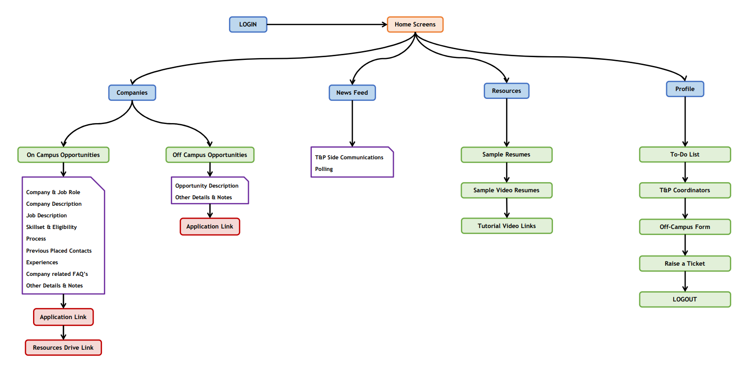

Fig. Workflow Diagram for Mobile Application

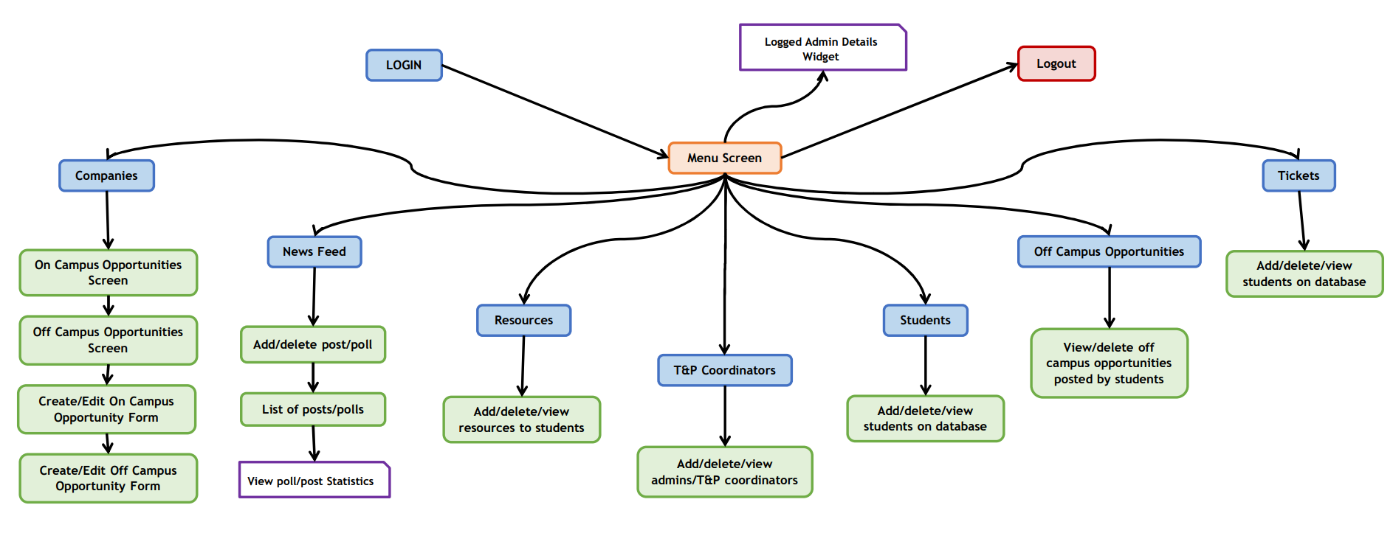

Fig. Workflow Diagram for Website

**RESULTS**

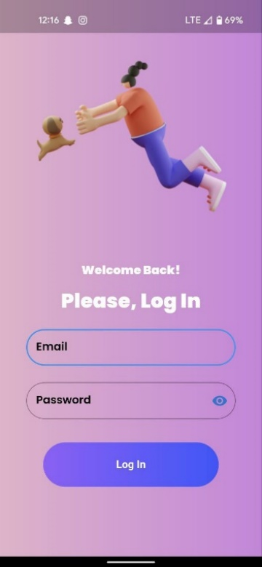 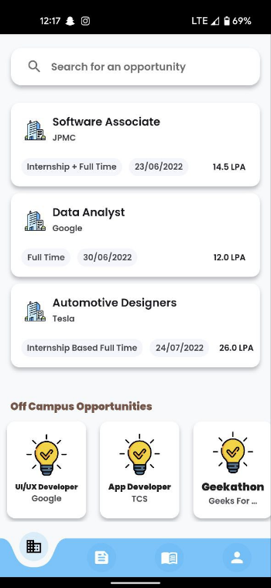 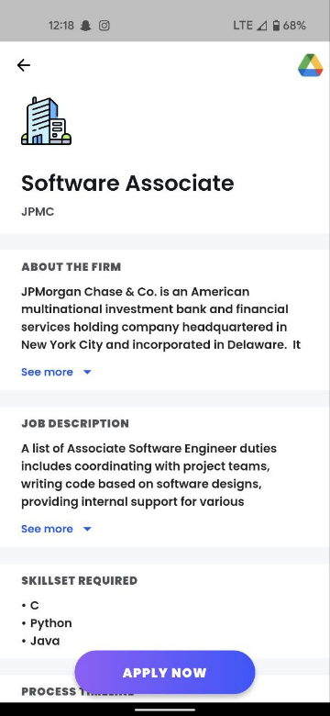

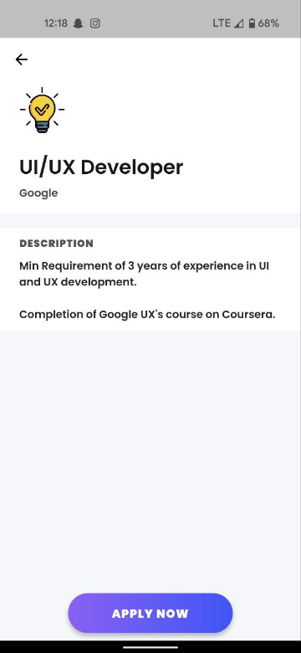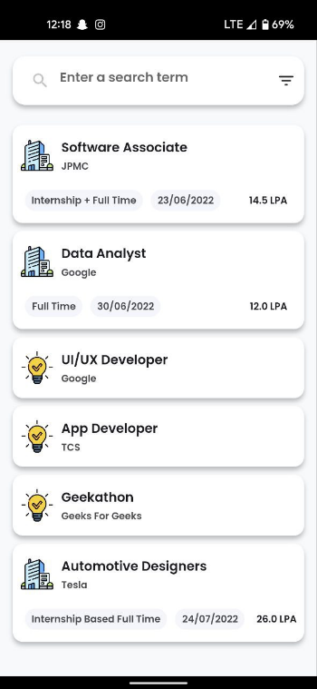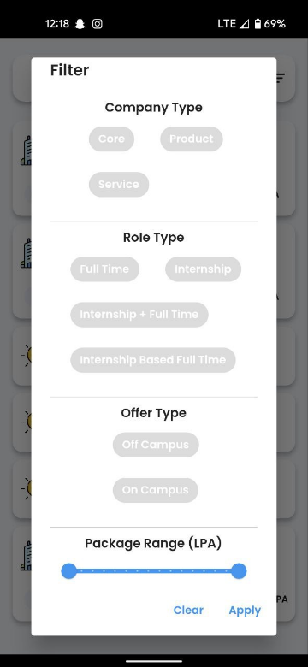

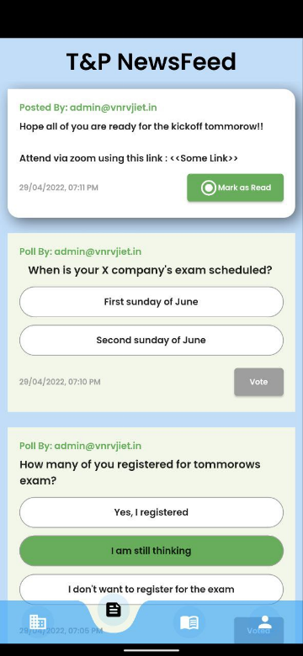 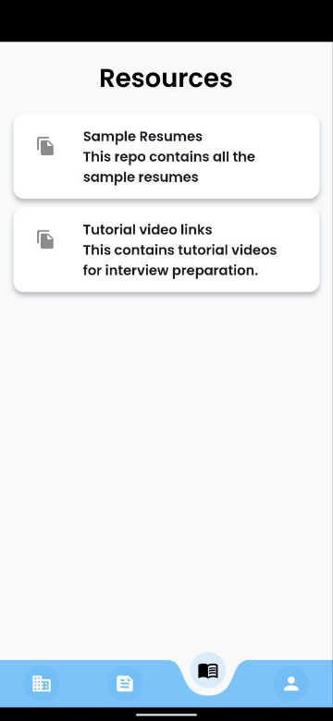 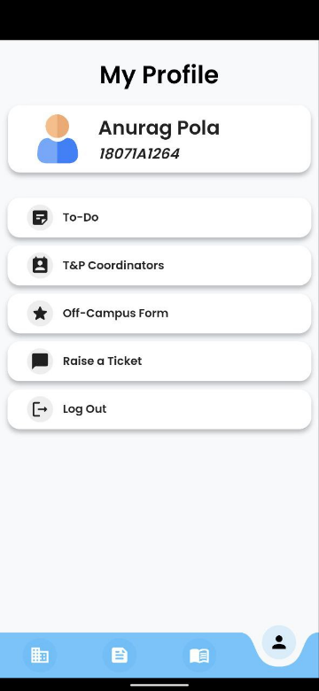

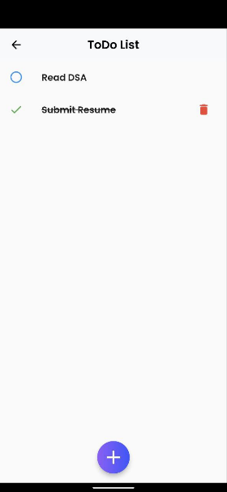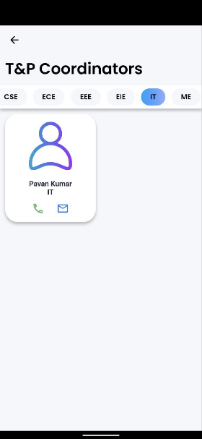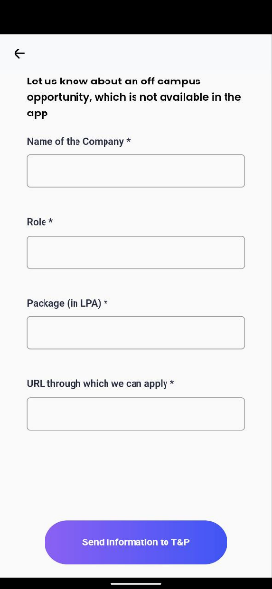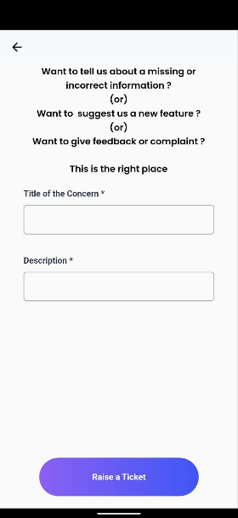

Fig. Mobile Application Output Screenshots

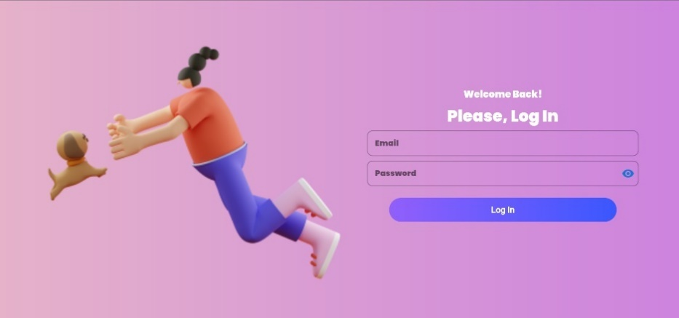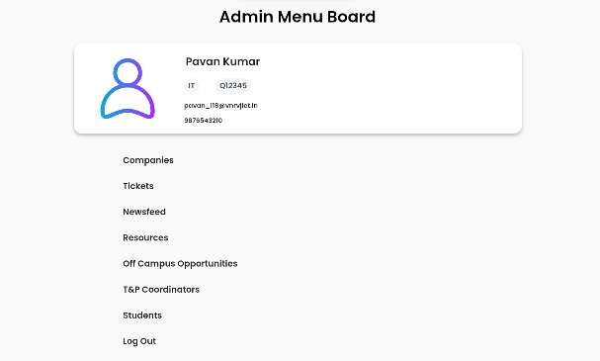

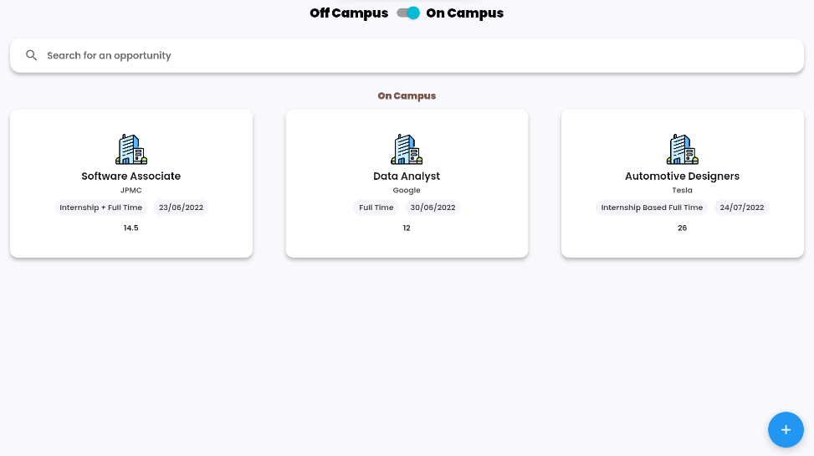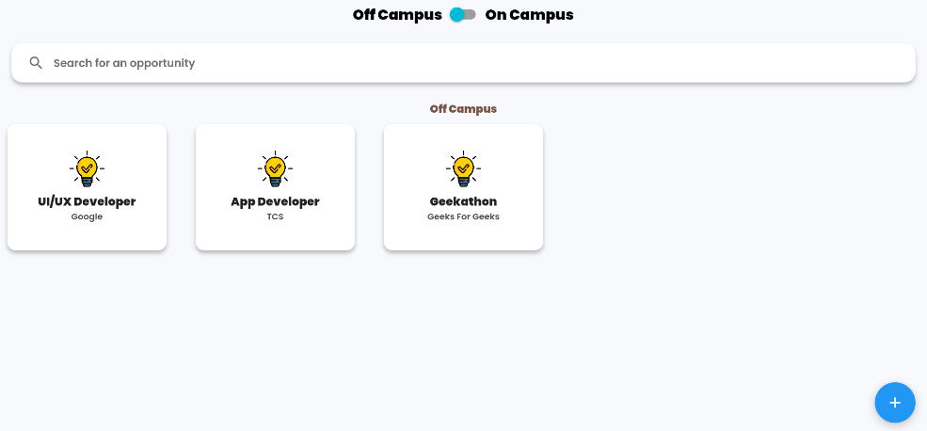

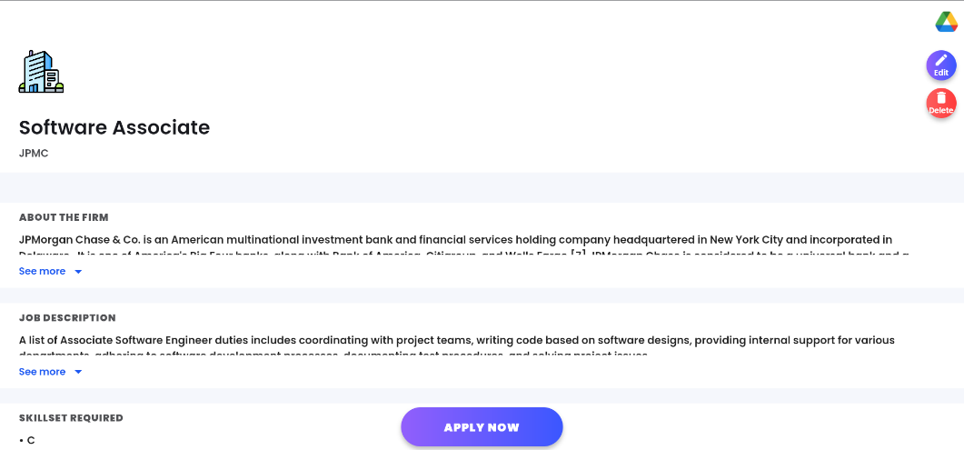 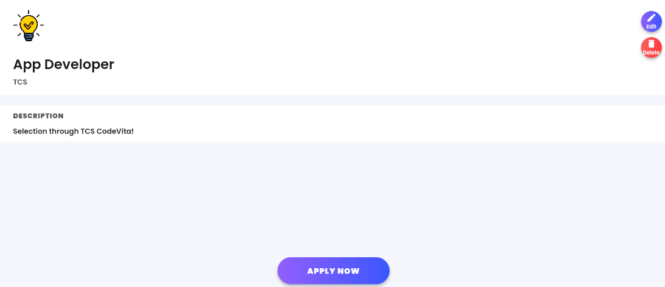 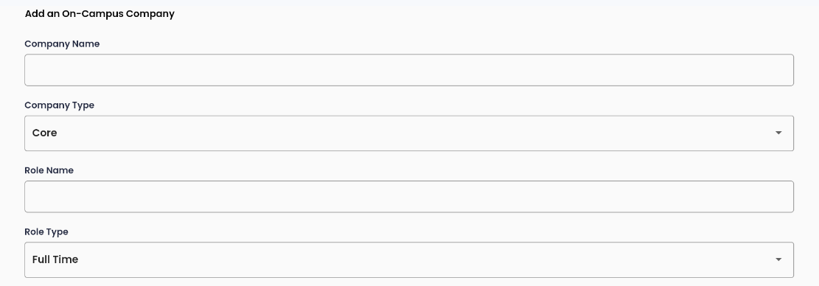 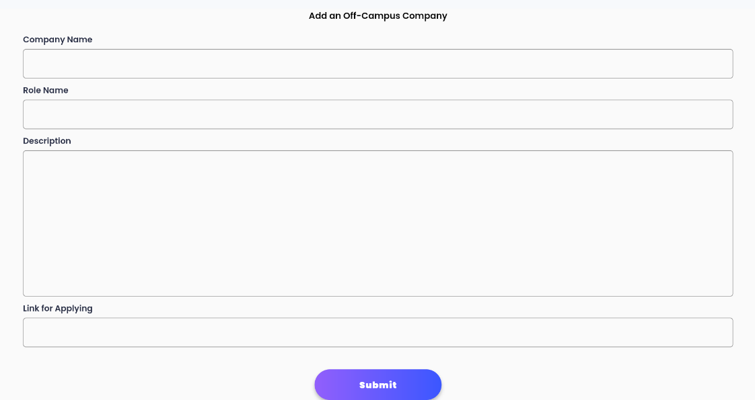

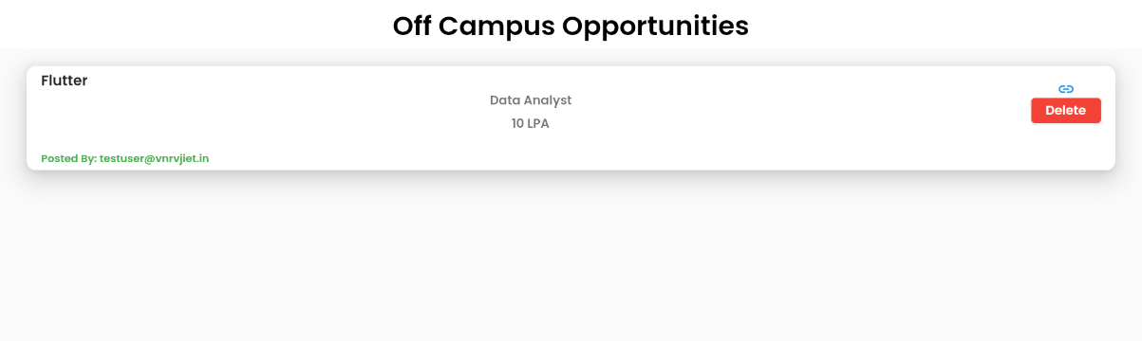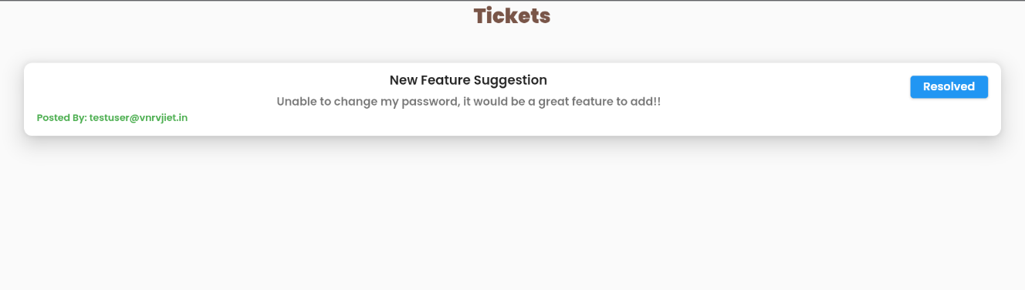 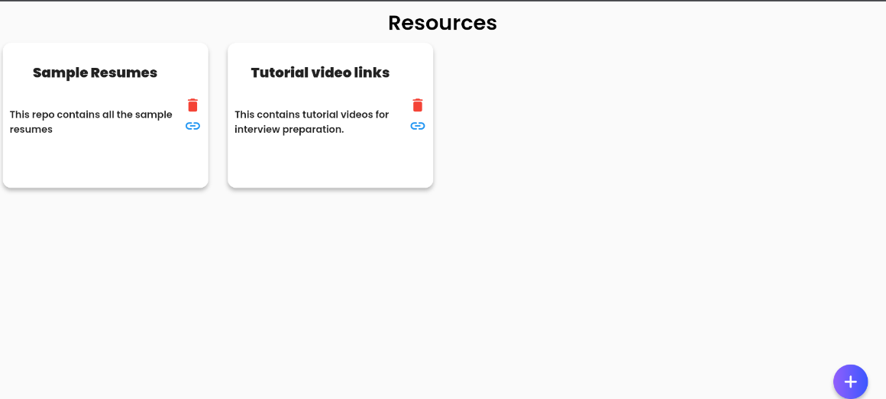

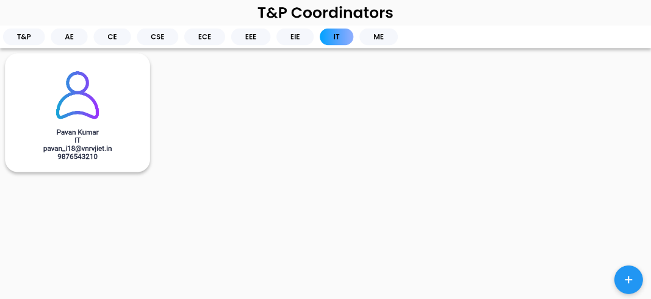 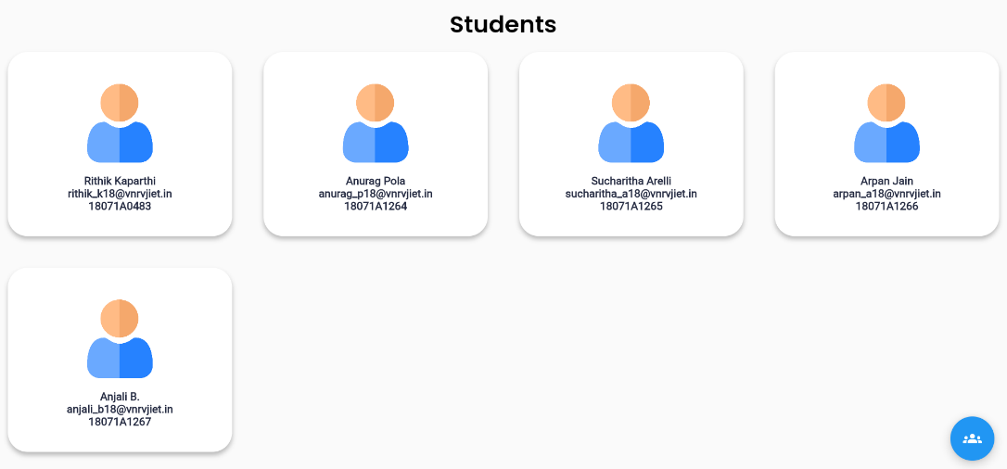

Fig. Website Output Screenshots

**CONCLUSION**

Placementor, both App and Website combinedly, would constructively help the college and students to have the process of placements being seamless and effective.

Based on the existing solutions, we considered their advantages and disadvantages and tried to integrate all the positive points while also trying to reduce the negative points in them to create a new solution for our college. The UI/UX has been built in such a manner that the user would get most of his/her placement related needs at his/her fingertips without confusion. All the information and functionalities have been embedded into the application (Both App and Website) in an easily understandable and usable manner.

It would reduce the work needed by placements team at the same time giving the maximum information to the student so that they can reach their goals. A complete two-way bridge of communication will be built between the college and students to ensure maximum efficiency from both of them.

**FUTURE SCOPE**

The solution can be improved and extended to make it more feasible. Some of the extensions are mentioned below.

1. **Integration with Eduprime**

The application can be directly integrated with Eduprime, our college’s one stop for all the information of a student and share data in both directions which would benefit the application as well as college.

1. **Providing the same services in other colleges**

The same application can be customized according to needs of other colleges and can be supplied to them.

1. **Direct Integration with companies**

Companies can be directly contacted and can be asked to give their placements via the mobile app removing the burden of placements team of colleges.

1. **Providing placement status tracker and personalized trainings to students**

Students can track their placement timeline for all opportunities they have applied for. For placements, they can be provided with personalized training so as to boost performance.

1. **Overview of placements to college and public**

Providing a complete statistical view of placements in the form of numbers and visualizations to T&P department, Management and Public.

**SHOW & TELL**